Welcome New Beauty Consultant!
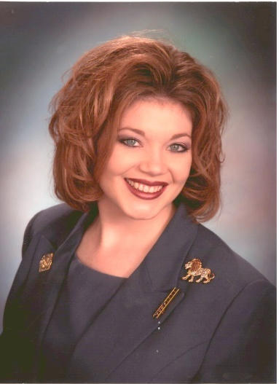Lisa Salada, Senior Sales Director
133 Sawbuck Trail Abilene, TX 79602
Office: 325/232-6545 mobile: 850/240-5545
Email me: lsalada@marykay.com

My name is Lisa Salada. I am your Sales Director. I want to tell you a little about myself, this organization and how you fit in so you won’t be confused. I have been in Mary Kay since December of 2000. I started in this company to get my product at half price. But soon after, I found that I could really make money selling Mary Kay and it was fun. I am a Registered Nurse and have been since 1995, my area of expertise was emergency nursing. I am no longer working full time as a Nurse, and am working my Mary Kay business full time. Within my first year in Mary Kay, I earned the use of a free car! I hope you will want to do this too, because it was the best thing I could’ve done to get my family to be excited about this business. Please understand your family and friends will take this business as serious as you do. As you become more familiar with how we do things in Mary Kay, the following will make sense, but until then, just keep the following information in a safe place. Our unit number is AJ41. We are in the Sharon Buck National Area and our seminar affiliation is Diamond. You will be receiving emails from my assistant You can read it at your leisure. We will be training on it in new consultant orientation. I encourage you to listen to the CDs quickly (you get a prize if you do) and please feel free to call me for any questions that you may have.
Mary Kay is awesome, and you are very wise to have made the decision to join this Fortune 500 Company. This will be a wonderful journey and I am here to help you in any way I can. Please keep my number in a place where it is easy to find and know that I can’t wait to hear from you for any reason. Let’s begin this journey together by having you fill out the Consultant dream card worksheet and a copy of your primary contact list as well as your DISC test then send them in to me within the next 24 hours for your 1st PRIZE. You can hand this to me at Success Meeting, mail it to me, or feel free to fax it to me. Also, it is imperative that you get plugged in for training and we start your business off on the right track, so please contact me about how to move forward. I can’t wait to get to know you and your family. This is the beginning of the best time of your life!!!
Can’t wait to hear from you!
Lovingly, Lisa

